Getting Started with Office 365 Development
Lab Time: 45 minutes
Lab Folder: C: \Student\Modules\01_GettingStarted\Lab
Lab Overview: In this lab you will get up and running with an azure/Office 365 development environment. You should be working with a Windows PC that has been set up according to the Setup.docx document that accompanies this course. You will perform the necessary tasks of creating a new Office 365 trial account which will create an Azure Active Directory (AAD) tenant that you will use for your development environment. Once you have created your Office 365 trial, you will then create a trial subscription for Microsoft Azure (unless you already have an Azure account that you can use. At the end of the lab you will use PowerShell libraries for Microsoft Azure and SharePoint Online to verify you can connect to your Office 365 and Azure accounts with a PowerShell script.

Exercise 1: Download a Local Copy of the Student Lab Files
In this exercise, you will use the GIT utility to download a local copy of the student files for CBD365. Note that this exercise assumes that GIT has already been installed on your PC as discussed in the setup guide for this course.
- Launch a browser and navigate to the GitHub repository for this course at the following URL.
https://github.com/CriticalPathTraining/MSD365
- You should see the home page for the repository as shown in the following screenshot.
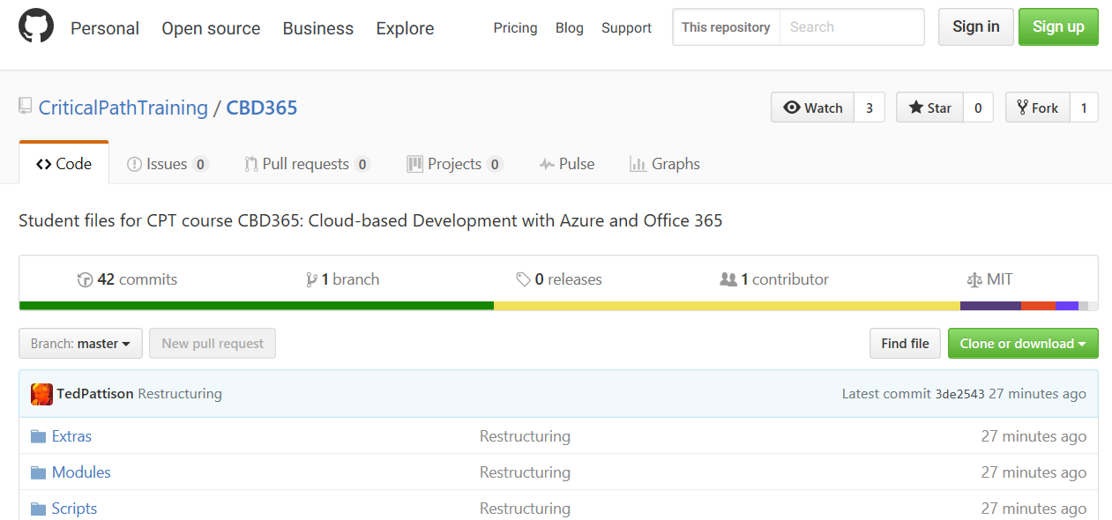
- Copy the URL to clone the repository.
  - On the home page of the CBD365 repository, click the green Clone or download dropdown menu.
  - Click the Copy to clipboard button to copy the URL for cloning to the Widows clipboard.
- Use GIT to clone the MSD365 repository.
  - Open up a Windows PowerShell command prompt.
  - Type in and execute the following git command to download the student files to a local folder named C:\Student. Note that you copied the URL to github.com in the previous step and you can paste it from the Windows clipboard instead of typing it it.
git clone https://github.com/CriticalPathTraining/MSD365.git C:\Student
  - When the git clone command runs, it will create a local copy of the repository on your local machine in the C:\Student folder.
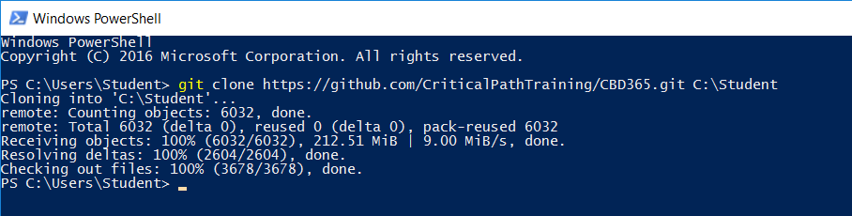
  - When the git clone command completes, open Windows Explorer and examine the Student folder. You should be able to see the Student folder has child folders named Extras, Modules and Scripts.
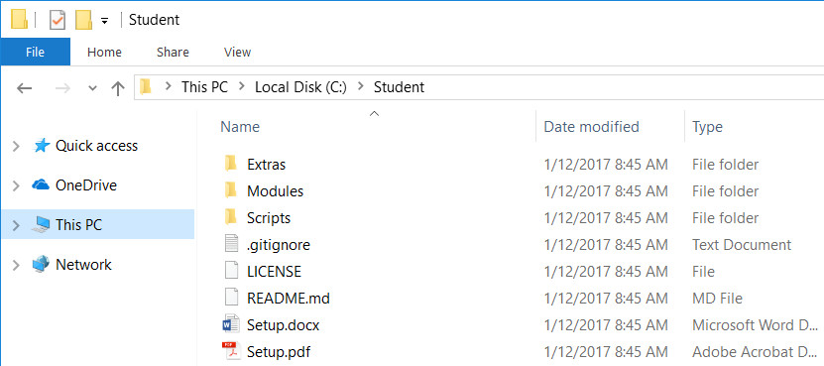
  - Drill into the Modules folder and look in the folder inside named 01_GettingStarted.
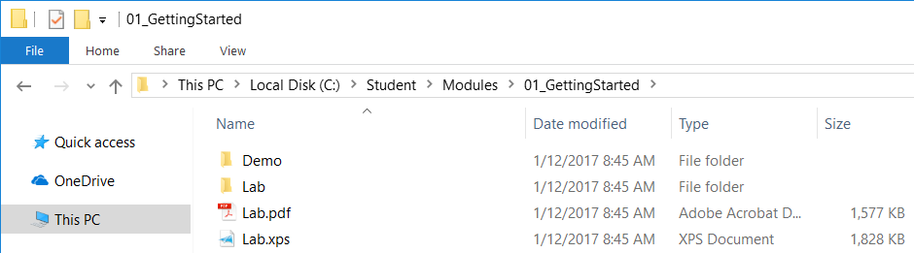
You can see that the 01_GettingStarted folder contains two child folders named Demo and Lab.

Exercise 2: Create an Office 365 Trial Account
In this exercise, you will create a new trial Office 365 which in turn will create a new Office 365 tenant. This Office 365 tenant will allow you to create up to 25 user accounts with Enterprise E5 trial licenses. Note that the Enterprise E5 trial license provides the benefits of the Office 365, SharePoint Online and Power BI Pro. Being able to create multiple Office 365 user accounts in your cloud-based testing environment will be important so that you can test the effects working with multiple users.
- Navigate to the following URL:
https://go.microsoft.com/fwlink/p/?LinkID=698279&culture=en-US&country=US
- Fill out the form with your personal information and click Next.
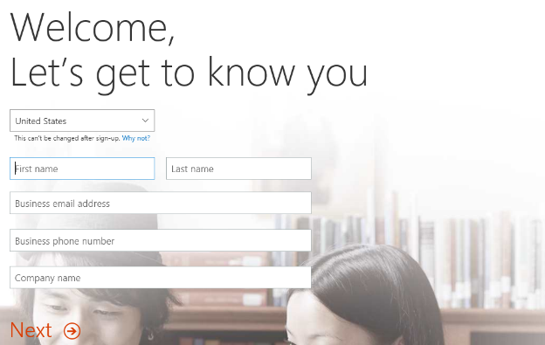
The information you provide here will be used throughout your tenant so if you do not wish to use your actual company name then you can provide a humorous and/or fictitious company name. The name you use for company name will turn out to be the name of the Office 365 tenant that you are creating.
- On the next page, you are prompted to provide a user ID, company name and password.
Note that the company name you enter on this page will be used to create the domain name for your new Office 365 trial tenant. For example, if you were to enter a company name of CBD365, it would result in the creation of a new Office 365 tenant within a domain of CBD365.onMicrosoft.com. The user name you enter will be used to create the first user account which will be given administrative rights within the trial tenant. If you enter a user name of Student, then the email address as well as user principal name for this account will be Student@CBD365.onMicrosoft.com.
- Enter a user name and a company name (i.e. domain name) for your new Office 365 trial tenant. For the company name, you may wish to simply use your first and/or last name with a number which you can increment each time you have to create a new trial account (e.g. EricClapton1.onmicrosoft.com).
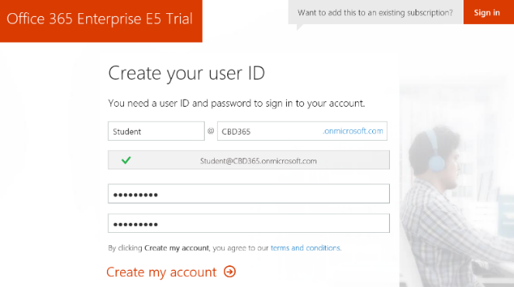
Don’t use your actual company name as that may cause some conflict when your company decides to create their own official tenant. Throughout the remainder of this guide you will see a company domain name of CBD365 which you should replace with the value specified for your company name.
- Complete the validation form in step 3 by proving you are not a robot.
  - Select the Text me option and provide the number of your mobile phone.

  - When you go through this process, a Microsoft online service will send you a text message that contains an access code.
  - You can then retrieve the access code form your mobile device and use it to complete the validation process.
- Once you have completed the validation process, click the You’re ready to go… link to navigate to the portal welcome page for your new Office 365 trial tenant. Note that you should already be logged on using the user account that was created during the sign up process.
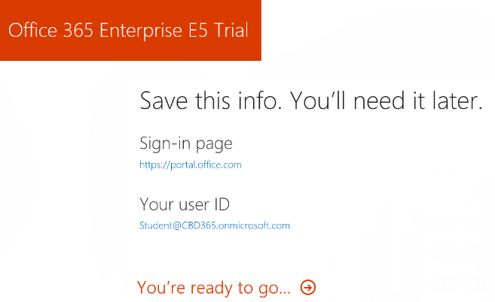
At this point, you have already created a new Office 365 tenant which can support creating up to 25 user accounts with Office 365 Enterprise E5 trial licenses. Note that some Office 365 services within your new Office 365 tenant such as the Office 365 admin center can be accessed immediately. Other services within your Office 365 tenant such as SharePoint Online are not ready immediately and will take some time to provision.
- You should now be located on the portal welcome page of the Office 365 portal. You will notice that this page shows the progress of the Office 365 environment in provisioning each of the individual services that make up your new Office 365 trial tenant. Click the Admin tile to proceed to the Office 365 admin center.
- You will be presented with the Office 365 admin center welcome dialog, close it by clicking the X menu in the upper right corner.
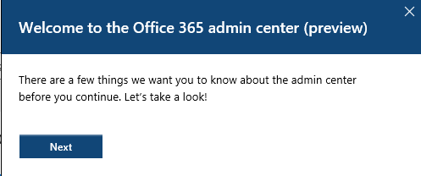
- Verify that you are able to access the home page of the Office 365 admin center.
  - The following screenshot shows what the Office 365 Admin center looks like with the new user interface experience.
  - Locate the top Menu button for the left navigation menu. It’s the second button from the top with the arrow icon which sits just beneath the Office 365 App Launcher menu button.
  - Click the top Menu button several times and see how it toggles the left navigation between a collapsed and expanded mode.
If you are interested in getting more familiar with the Office 365 admin center, take a minute to explore the administrative pages behind the left navigation menu in the Office 365 admin center.
- Install the Office 2016 client applications.
  - Locate and click on the Install my software link on the home page of Office 365 admin center.
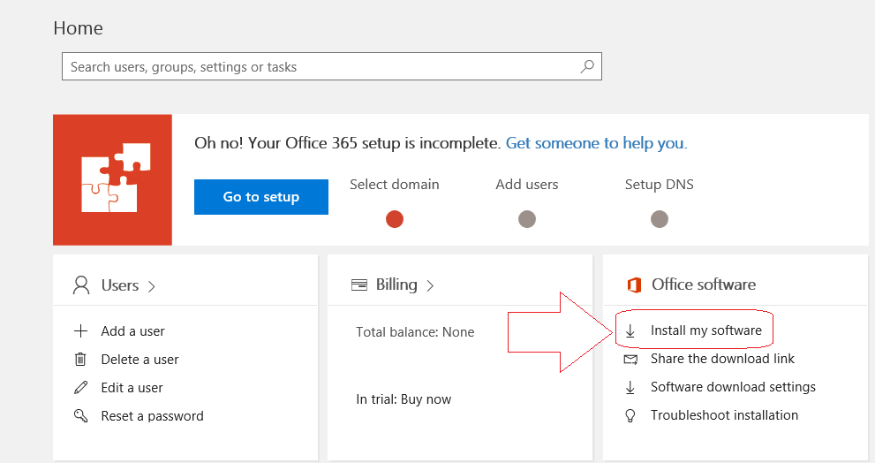
  - You should now be at the Office tab of the Software page. Locate and click the Advanced link to set the installation option to install the 64-bit version of Office 2016 instead of the 32-bit version.
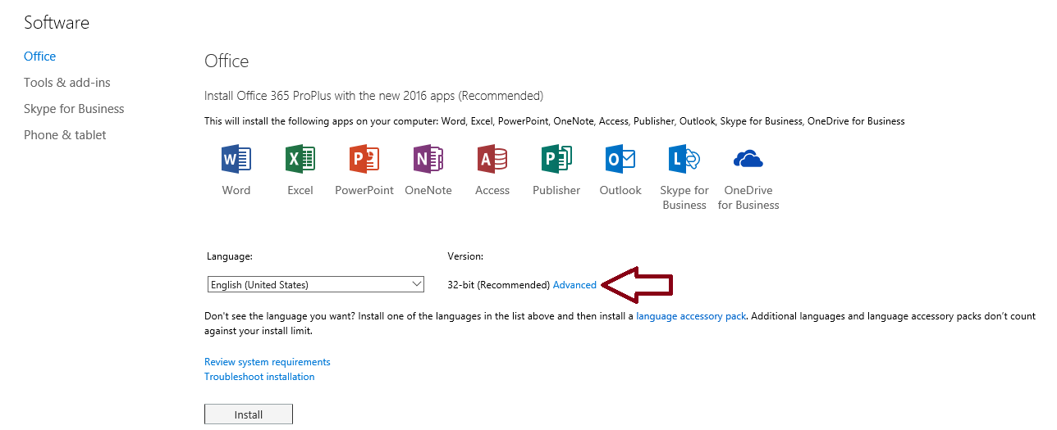
  - Use the dropdown menu to change the Version setting to 64 bit. And then click the install button to begin the installation.
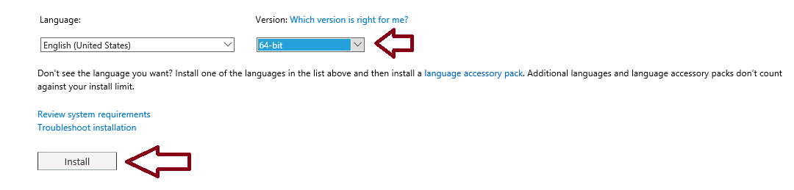
  - Follow the instructions to install Office 2016.
There is no need to wait once the installation of Office 365 has begun. You can move ahead and continue with the next step while Microsoft Office is installed in the background.
- Make sure you can access your Office 365 inbox to read and send messages.
  - Click on the Office 365 App Launcher menu button in the top-left corner of the page.

  - Click the Mail tile button in the App Launcher menu to navigate to Outlook Web Access (OWA).
  - If prompted, specify your language and time zone for Outlook.
  - You should now see a web page with the Office 365 Outlook web access client and a view the Exchange inbox that is associated with the primary user account that was created when you created the Office 365 tenancy.
  - Test your email account by sending a message to one of your other email addresses, Display the form to create a new email clicking the New button. If the New button is not showing, it’s probably because the form to create a new email is already showing.
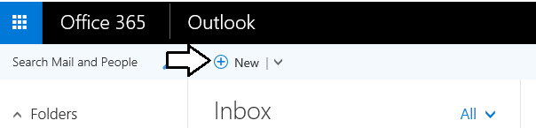
  - At this point, you should see the Outlook form to create new email on the right side of the page.
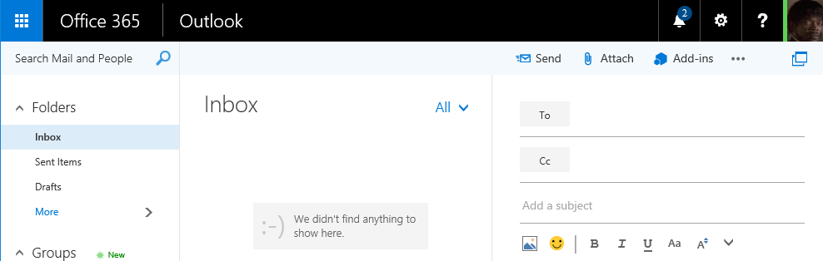
  - Fill out the new email form using sample data (see example below) to send a test message. Be sure to send the test message to an email address that is yours. Click Send when it’s ready to go.
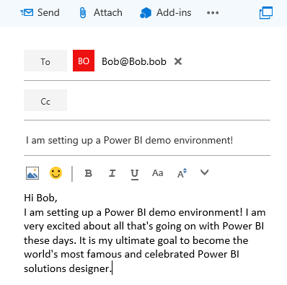
  - Click Send to send the email.
  - Check the email account you sent the email to and verify that you received the email.
  - Reply to the email to verify that you can send an email to your new account.
  - Return to the Outlook Web Client and verify receipt of your reply.
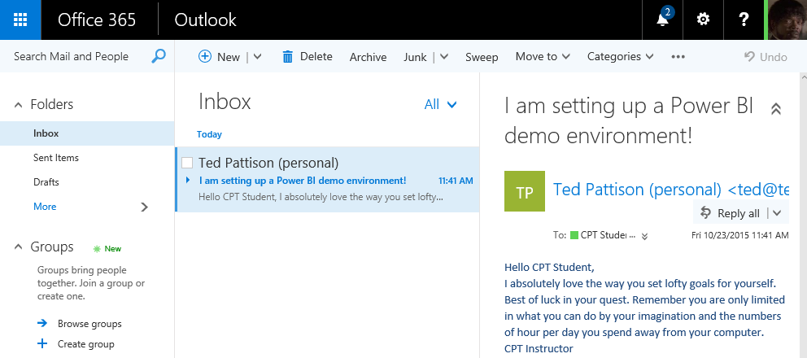
Having access to mail is valuable when you are working with Office 365 and Microsoft Azure. That's because the Office 365 and Microsoft Azure often use email messages to send invitations and notification to users is response to user actions.

Exercise 3: Create an Azure Trial Account
In this exercise you will create a trial Azure subscription using the primary account that was created in your Office 365 tenant.
IMPORTANT: Over the steps of this lab exercise, it is critical that you authenticate using the primary Office 365 user account that was created for you when you created the Office 365 tenancy earlier in this lab. Make sure you do not log into any site on the Internet using any personal account or organization account other than your primary Office 365 user account. If you have logged on to any site using another account, then you should close all browser instances and then launch a new browser session for this exercise.
Note that if you already have an Azure subscription, you can use your pre-existing subscription instead of creating a new trial subscription. Also keep in mind that Microsoft has a policy that only allows for one free trial subscription per person. If you have already created a trial subscription in the past, you might need to register for the new trial using a different email address, mobile phone number or credit card number.
- Sign up for a free Microsoft Azure trial account using your primary Office 365 account.
  - Navigate to https://azure.microsoft.com/en-us/free/.
  - Click the Start Free button to go to the sign up screen to navigate to the Free trial sign up page.
  - Once you get to the Free trial sign up page, start by looking at the logged in user name in the top right corner of the page and verify that you are logged in under the identity of your primary Office 365 user account. Also verify that the Country/Region setting is correct. Fill in the rest of the information requested in the About you section and then click Next.
  - In the Identity verification by phone setting, enter the phone number of your mobile phone and click the Send text message button. Wait until you receive a text message with your access code.
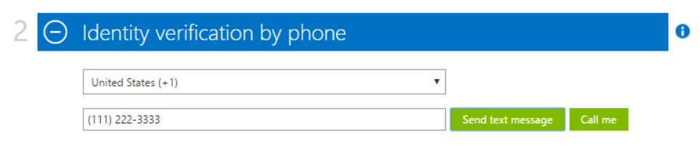
  - Once you receive the text message with the access code, enter the access code in the bottom textbox and click the Verify code button.
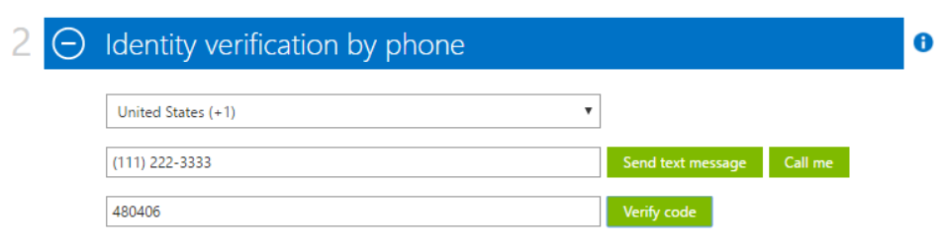
  - In the Identity verification by card section, you must enter the information for a valid credit card. This is a required step. Once you have entered the credit card information, click the Next button to verify the credit card information.
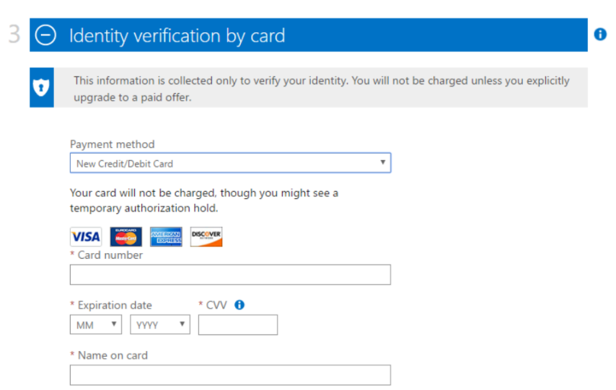
Note that Microsoft will not charge your credit card for any type of Azure usage as you work with new your free trial subscription. However, your credit card information is retained by Microsoft in case you upgrade your free trial to a pay-as-you-go subscription.
  - Complete the final step in the Agreement section by checking the I agree checkbox and clicking the Sign up button.
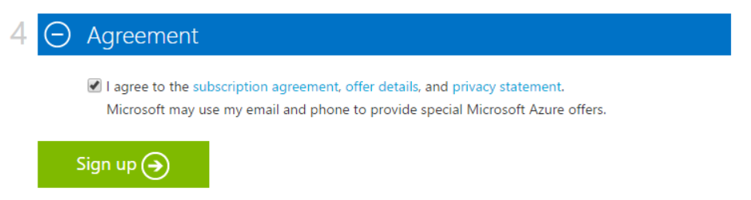
  - You should now see a page that indicates your free trial Azure subscription has been created.
  - Once the setup process completes, click on the big button on the page to navigate to the new Azure portal.
  - You should now see the main page of the Azure portal which displays the dashboard and the left navigation menu.
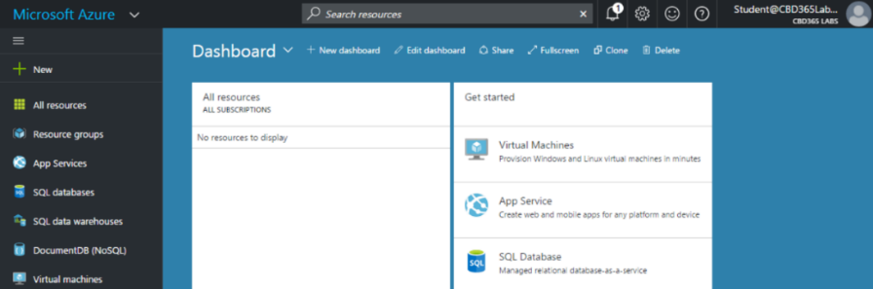
  - Locate and click the Billing link which is down toward the bottom of the left navigation menu.
  - When you click Billings, the Azure portal will display a pane which shows your subscriptions at the bottom. Note that this view allows you to see and copy the GUID associated with your subscription. Note that you should copy this GUID and save it to a local text file because you will need it in later lab exercises.
Now that you have an active Azure subscription, it's time to test out this subscription by using a few Azure PowerShell commands.

Exercise 4: Connect to Microsoft Azure using PowerShell
In this exercise, you will use the Azure ARM PowerShell module to verify PowerShell connectivity to your Azure subscription. Note that this exercise assumes you have already installed the Azure PowerShell modules as discussed in the lab setup document.
- Open up a PowerShell command prompt.
- Use PowerShell to establish a login to Microsoft Azure
  - Type and execute the following PowerShell command to establish a login to Microsoft Azure.
Login-AzureRmAccount
  - The first time you execute the Login-AzureRmAccount cmdlet, you might be prompted as to whether you want to allow Azure PowerShell to collect data. If you see this prompt, you can answer with either a Y or an N.
  - When the Login-AzureRmAccount cmdlet begins to execute, you will be prompted to sign in. Enter the credentials of your primary Office 365 user account and click Sign In.
  - When the Login-AzureRmAccount cmdlet executes successfully, it displays the information shown in the following screenshot. You should be able to see the GUID for your Office 365 tenant as well as the GUID for your Azure subscription.
Make sure you see a SubscriptionId value for your Azure subscription. If you have more than one Azure subscription, you might need to make one of them the active subscription by calling the Set-AzureRmContext with the SubscriptionName parameter.
  - Type and execute the Get-AzureRmADUser cmdlet to display the users in your Office 365 tenancy.
Get-AzureRmADUser
  - When Get-AzureRmADUser executes, it should display information about the user accounts in your Office 365 tenancy. At this point, you should have a single user account which is your primary Office 365 account.

Exercise 5: Connect to SharePoint Online using PowerShell
In this exercise, you will use the SharePoint Online PowerShell module to verify connectivity to your Azure subscription. Note that this exercise assumes you have already installed the SharePoint Online Management Shell as discussed in the lab setup document.
- Connect to SharePoint Online and sign in using PowerShell.
  - Run the following command to connect to your SharePoint Online tenant. Be sure to replace [your tenant] with the value you provided when creating your Office 365 tenant (this will be the same value that is preceding onmicrosoft.com in your login).
Connect-SPOService -Url https://[your tenant]-admin.sharepoint.com
  - When the Connect-SPOService cmdlet begins to execute, you will be prompted to sign in. Enter the credentials of your primary Office 365 user account and click Sign In.
Once you have established a login session by calling Connect-SPOService, you can now begin to use the other SPO cmdlets.
- Execute a few more SPO cmdlets to view information about existing site collections in your Office 365 tenancy
  - Type and execute the following command.
Get-SPOSite
  - You should see that the call to Get-SPOSite displays the set of site collection in your Office 35 tenancy.
- Create a new Site Collection using the New-SPOSite cmdlet.
  - Execute the following lines of code to set up a few variables for the new site. Be sure to replace [Your tenant] and [Your User Account] with the value you provided when creating your Office 365 tenant
$url = "https://[Your Tenant].sharepoint.com/sites/MyTeamSite"
$owner = "[Your User Account]@[Your Tenant].onMicrosoft.com"
$quota = 1000
$siteTitle = "My New Team Site"
$template = "EHS#1"
  - Execute the New-SPOSite cmdlet to create a new SharePoint site in SharePoint Online.
New-SPOSite -Url $url -Owner $owner -Title $siteTitle -StorageQuota $quota -Template $template
  - Wait until the call to New-SPOSite completes. This usually takes 1-2 minutes.
  - Execute another call to Get-SPOSite and make sure you see the new site collection you just created.
  - Execute the following PowerShell command to get more information about the new site.
Get-SPOSite -Identity $url | select *
  - You should see a list of properties similar to what you can see in the following screenshot.
  - Note that there is a small bug in the SPO PowerShell cmdlets when you call New-SPOSite. In particular, it does not assign the site title correctly. You can fix this problem by running the following PowerShell command to assign a site title for the new site.
Set-SPOSite -Identity $url -Title $siteTitle
- Run the following PowerShell command to open the new SharePoint site in the browser.
Start-Process $url
- Take a moment to inspect your new SharePoint Online site.
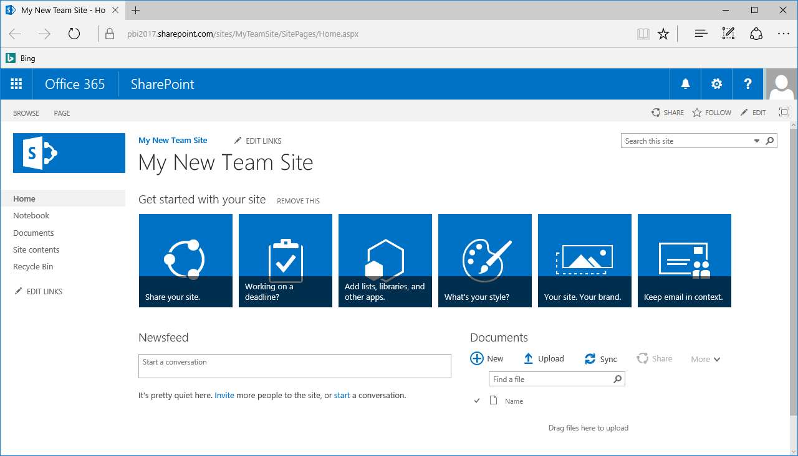
You have now reached the end of this lab.

